**Episode 4**

#create table

hive> CREATE TABLE episodesIV_counts

> (character STRING, dialouges STRING)

> ROW FORMAT DELIMITED FIELDS TERMINATED BY '\t'

> TBLPROPERTIES ("skip.header.line.count"="1");

#load data

hive> LOAD DATA LOCAL INPATH

> '/shrikant/episodeIV_dialouges.txt'

> INTO TABLE episodesIV_counts;

#Exports to HDFS directory

hive> INSERT OVERWRITE DIRECTORY '/user/root/output/lukeLines'

> SELECT dialouges FROM episodesIV_counts where dialouges rlike '.*(Luke).*';

#check results in HDFS

dfs -cat /user/root/output/lukeLines/000000_0

#check results in local

hdfs dfs -get /user/root/output/lukeLines/000000_0 /episodeIV/lukeLines

cat /episodeIV/lukeLines /000000_0

Episode 4 line results with Luke HDFS

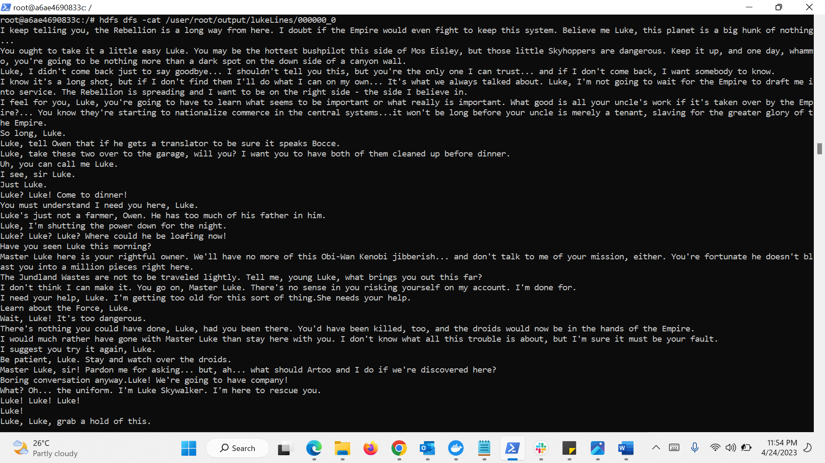

Episode 4 line results with Luke local

